EasyRG – Handbook

Overview

This program processes and analyzes raw experimental data files using a configurable R workflow. Before running the analysis, users must:

- Install required R packages
- Specify input/output file paths
- Define grouping variables
- Create an Excel sheet containing metadata

This handbook will explain how to complete each of these steps and run your code. If you are completely unfamiliar with R, I suggest starting with the R Studio education for beginners: https://education.rstudio.com/learn/beginner/

Link to GitHub repository: annakalaani/EasyRG: an all-in-one tool for automatic bulk analysis of ffERG waveforms in preclinical studies - ERG made easy!

1. Installation
Download and install R
If you do not already have R and Rstudio on your computer, you can find the download here: https://www.r-project.org

Install Required R Packages

Run the following in R:

install.packages(c(
"tidyverse",
"xlsx",
"signal",
"flextable”,
“shiny”,
“DescTools”
"broom",
))

If prompted during runtime, install any missing dependencies.

2. Preparation of data
Create a folder containing all your raw data files. This folder must contain all data you want to analyse and must not contain any other files.

Create the metadata file which will connect the raw data to your experimental information. Make sure to consult the metadata template to set up your file properly.

One of the variables that must be filled in in this file is the PatId. The PatId can be found in your raw data files and will be used to connect the raw data to the correct metadata. The image below depicts the location of the PatId.
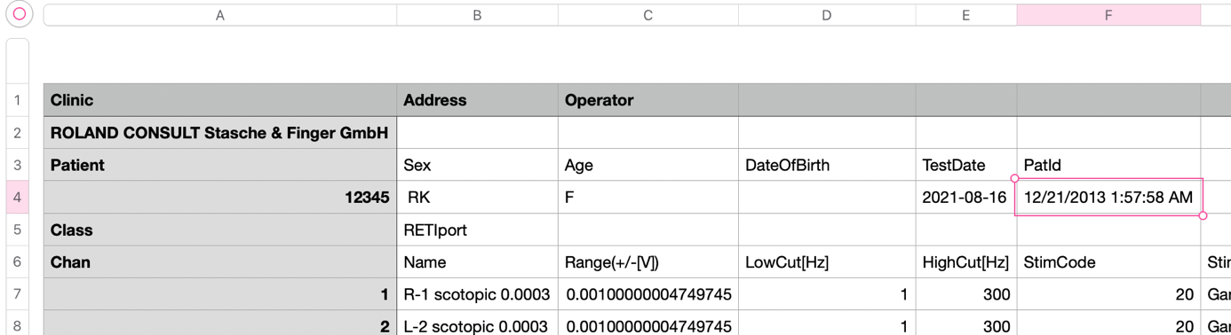

The other variables include:
- “identifier” which is used to identify each individual animal. This can be an animal number or name, for example.
- “gender” which should be specified as M or F.
- “genotype”, e.g. “WT” or “KO”.
- “timespan”, which should be filled in as a number only.
- “treatment_left” and “treatment_right”, which specify a treatment administered per eye. If both eyes received the same treatment, simply fill in the same for both eyes.

Do not leave any of the fields blank to avoid errors. If there is no treatment, for example, just fill in “Not treated” or similar.

Create a folder where the output of the data analysis will be stored.

If you have incompatible raw data and want to start with pre-processed data, please read “6. Incompatible raw data” before starting.

3. Define paths and variables
You can now start setting up the program to run your data.
The program starts with a chunk which contains all variable that you can/must change. You do not need to check the rest of the code.

Set pathnames
The chunk starts with the note “Please set your pathnames here”. Underneath you must fill in the pathnames for your input folder (containing all your raw data), your metadata file, and your output folder. To find the pathnames:

On Mac: find your file/folder > right click > hold option > click “Copy *your file/folder name* as Pathname

On Windows: find your file/folder > hold shift > right click > click “Copy as path”

Set parameters
The next note says, “Please set your parameters here”.

First set your time label. For example, “Age in weeks”, “Days since treatment”, or “Time (hours)”. In the metadata file, you are defining time simply by filling in a number. The label you fill in here will define this number and will help to make your graphs easier to read. There are no rules for what you fill in for this parameter.

Secondly, set your grouping variable. This is an important parameter, because it specifies how the program will group your data. For example, if you are comparing animals with different genotypes, you will want to set this to “genotype”. But if you are comparing animals with a different treatment, you will want to set this to “treatment”. The label you fill in here must match the metadata file exactly. To simplify, we provide a list of your options below:

- “genotype”
- “gender”
- “treatment”
- “timespan”

NOTE: the ANOVAs are by default two-way with your grouping variable as the first variable and the timespan as the secondary variable. If you set “timespan” as your grouping variable, the ANOVA becomes one-way. The automatic plots cannot accommodate this one-sided design automatically, but you can still use the data output from excel to make your own plots.

Optional changes
The next few lines will ask you if you do or do not want to change certain things in the program. You can simply change these parameters from TRUE to FALSE (or vice versa) depending on your preferences.
By default, the program will not plot waveforms per animal individually, it will plot an overview of all waveforms after every filter, and it will not set NA values to zero.

Time settings
Our ERG machine makes 512 measurements over 350 ms for each waveform, by default. If your settings are different, you can change these values here.

Changing filters
The standard filters used by the program are optimized for data from Brown Norway rats. If you are using a different animal model, tweaking the filter wavelengths may improve results.
Simply change the wavelengths here to a different number.
If you are trying out different filters, we recommend setting the plotting options (under “optional changes”) to TRUE so you can see the effects of the filters easily.

Incompatible raw data
If you are uploading pre-processed data (see “6. Incompatible raw data”), set this to TRUE.

4. Running the program
That’s it! You are ready to run the program.
You can do this by either clicking run > run all, or by knitting it into a html or word file (html is standard).

NOTE: You may have to run the chunk called “setup” first if you run all chunks manually instead of knitting (this is the second chunk in the program).

5. Interactive plot
After running the main code in the R environment, you have the option to run the code for the interactive plot. This code is provided separately.
For the interactive plot to work, you have to run the main code in Rstudio first. It will not work if you’ve only knitted the code previously.
Then, simply run the code chunk for the interactive plot and it will pop up, allowing you to play around with the data and identify group differences intuitively.

6. Incompatible raw data
If you have incompatible raw data and want to upload your own, pre-processed data, you must structure the input file as follows:

identifier | Measurement_type | StimFreq | PatId | Volt
Animal number | Eye and stimulus | Stimulus frequency | Identifier to connect metadata | Voltage measurements separated by commas
1234 | R-1 0.03 scotopic | 0.200 | 12/1/2026 12:34:56 AM | -0.01, -0.02, -0.03, -0.04….
1234 | L-2 0.03 scotopic | 0.200 | 12/1/2026 12:34:56 AM | -0.01, -0.02, -0.03, -0.04….

You can fill in the pathname for this file under “input_folder” as usual. Then, make sure to change the setting “incompatible_data” to TRUE. Otherwise, the code will not run.
Other than that, you can use the code in exactly the same way. So you must still upload the metadata file and set all parameters as usual.

7. Example data
We provide sample data with corresponding metadata file for you to test the program with. The data files consist of three wildtype Brown Norway rats measured at various timepoints. To test the program using this data, we recommend grouping by gender.

